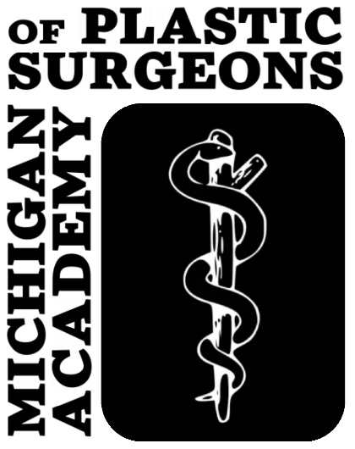

Michigan Academy of Plastic Surgeons
33rd Biennial Scientific Meeting
August 1-4, 2024
Grand Hotel, Mackinac Island, MI
CALL FOR ABSTRACTS
& Abstract Submission Guidelines

Back in 2024: Two submission categories will be considered by the Program Committee for oral/podium presentations:
- Original Research: customary 5- to 8-minute talks to report original results
- TED-style Talks: expert opinion/review-style presentations, typically by faculty, 10-15 min in length (will be considered for panels or stand-alone talks)
All abstracts should adhere to the appropriate TEMPLATE (attached):
- Software: Microsoft Word
- Margins: 1 inch on all sides
- Length: 1 page maximum
- Font: Times New Roman
- Title: Font Size 14, Bold, Centered – Do Not Use All Caps
- Authors/Affiliations: Font Size 12, Centered
  - Full Name, Degree (w/o periods), separated by a semi-colon
  - Affiliation(s) should be listed below Authors
- Body: Font Size 12, Block Style, Left-Justified
- Do not indent
- Tables and/or graphics are permitted, but must fit on 1 page
- Organization:
- Original Research: Please organize your abstract into these subheadings:
Objective, Methods, Results, Conclusion
- TED-style Talks: Please organize your abstract into these subheadings:
Intended Audience, Summary, Anticipated Duration
  - Corresponding Author Info
• Specify Abstract Category/Talk Contents and Presenter at bottom of page

Email Abstract as an attachment to: MAPSMeeting2024@gmail.com
by 11:59 PM on May 1, 2024

For additional information/questions, please contact:
Program Chair Anthony Zacharek, MD: MAPSMeeting2024@gmail.com

